Child Poverty in the Developing World

DAVID GORDON¹, SHAILEN NANDY¹, CHRISTINA PANTAZIS¹, SIMON PEMBERTON¹ & PETER TOWNSEND²

¹ Centre for International Poverty Research, University of Bristol, 8 Priory Road, Bristol BS8 1TZ
² London School of Economics, London

Correspondence and requests for materials should be addressed to D.G. (dave.gordon@bristol.ac.uk)

Child poverty is one of the greatest concerns of governments and international organisations,,. Here we report the first scientific measurement of deprivation and poverty of children in the developing world based upon agreed international definitions and high quality survey data,. Over one billion children – more than half the children in developing countries - suffer from severe deprivations of basic human need and over a third (674 million) suffer from absolute poverty (two or more severe deprivations).

Research has shown that all cultures have a concept and definition of poverty although these definitions often vary. A major problem with many previous attempts to measure poverty on a global scale was that there was no internationally agreed definition of poverty. This situation changed at the World Summit for Social Development in Copenhagen. Among the innovations agreed by the governments of 117 countries was the preparation of national anti-poverty plans based on measures in all countries of ‘absolute’ and ‘overall’ poverty.

Absolute poverty was agreed to be "a condition characterised by severe deprivation of basic human needs, including food, safe drinking water, sanitation facilities, health, shelter, education and information. It depends not only on income but also on access to social services."

Income is important but access to public goods – safe water supply, roads, healthcare, education – is of equal or greater importance, particularly in developing countries. There is a need to look beyond income and consumption expenditure poverty measures and at both the effects of low family income on children and the effects of inadequate service provision for children. It is a lack of investment in good quality education, health and other public services in many parts of the world that is as significant a cause of child poverty as low family incomes.

The two concepts of poverty and deprivation are tightly linked but there is general agreement that the concept of deprivation covers the various conditions, independent of income, experienced by people who are poor, while the concept of poverty refers to the lack of income and other resources which makes those conditions inescapable or at least highly likely.

Deprivation can be conceptualised as a continuum that ranges from no deprivation, through mild, moderate and severe deprivation to extreme deprivation at the end of the scale. Figure 1 illustrates this concept.

Figure 1: Continuum of deprivation

In order to measure absolute poverty amongst children using the World Summit definition, it is necessary to define the threshold measures of severe deprivation of basic human need for children. Theoretically, we have defined ‘severe deprivation of basic human need’ as those circumstances that are highly likely to have serious adverse consequences for the health, well-being and development of children. Severe deprivations are causally related to ‘poor’ developmental outcomes both long and short term.

The measures used were :

- Severe Food Deprivation– children whose heights and weights for their age were more than -3 standard deviations below the median of the international reference population, i.e. severe anthropometric failure.

- Severe Water Deprivation - children who only had access to surface water (e.g. rivers) for drinking or who lived in households where the nearest source of water was more than 15 minutes away (indicators of severe deprivation of water quality or quantity).

- Severe Deprivation of Sanitation Facilities – children who had no access to a toilet of any kind in the vicinity of their dwelling, including communal toilets or latrines.

- Severe Health Deprivation – children who had not been immunised against any diseases or young children who had a recent illness involving diarrhoea and had not received any medical advice or treatment.

- Severe Shelter Deprivation – children living in dwellings with more than five people per room (severe overcrowding) or with no flooring material (e.g. a mud floor).

- Severe Education Deprivation – children aged between 7 and 18 who had never been to school and were not currently attending school (no professional education of any kind).

- Severe Information Deprivation – children aged between 3 and 18 with no possession of and access to radio, television, telephone or newspapers at home.

Children who suffer from these levels of severe deprivation are very likely to be living in absolute poverty because, in the overwhelming majority of cases, the cause of severe deprivation of basic human need is invariably a result of lack of resources/income. However, there may also be some children in this situation due to discrimination (e.g. girls suffering severe education deprivation) or due to disease (severe malnutrition can be caused by some diseases). For this reason, we have assumed that a child is living in absolute poverty only if he or she suffers from multiple deprivations (i.e. two or more severe deprivations of basic human need as defined above).

The purpose of this study was to measure children’s living conditions that were so severely deprived that they were indicative of absolute poverty. Thus, the measures used represent more severe deprivations than the indicators frequently published by international organisations. For example, ‘no schooling’ instead of ‘non-completion of primary school’, ‘no sanitation facilities’ instead of ‘unimproved sanitation facilities’, ‘no immunisations of any kind’ instead of ‘incomplete immunisation against common diseases’, etc. We have, in the tradition of Seebohm Rowntree, tried to err on the side of caution in defining these indicators of absolute poverty in such severe terms that few would question that these living conditions were unacceptable.

Results
Severe shelter and severe sanitation deprivation are the problems affecting children in the developing world, with more than half a billion (34%) living in dwellings with more than five people per room or which have mud flooring. Over half a billion children (31%) have no toilet facilities whatsoever.

Figure 2: Percent of children severely deprived of basic human needs in developing countries

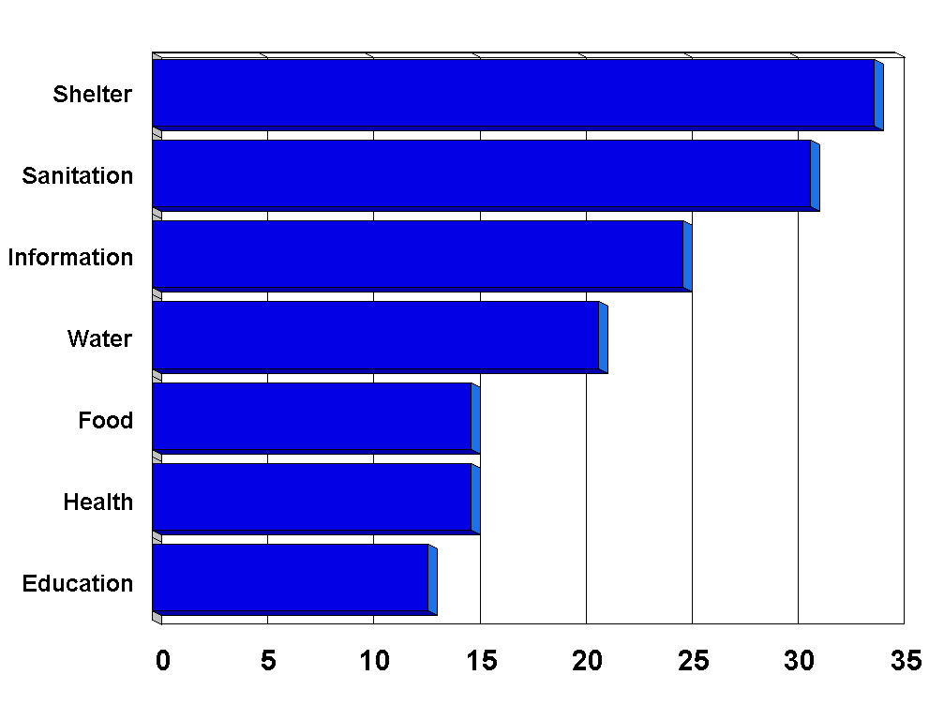

Almost half a billion children (25%) lack access to radio, television, telephone or newspapers at home and over 20% of children (nearly 376 million) are using unsafe (open) water sources or have more than a 15 minute walk to fetch water.

In the developing world, over 15% of children under five years old are severely malnourished and over half of these (91 million children) are in South Asia. Around 265 million children (15%) have not been immunised against any diseases or have had a recent illness causing diarrhoea and have not received any medical advice or treatment. Lastly, 134 million children aged between 7 and 18 (13%) are severely educationally deprived - they have never been to school.

There are differences both between and within regions (see Table 1). Sub-Saharan Africa has the highest rates of severe deprivation with respect to four of the seven indicators - severe shelter, water, educational and health deprivation. However, within the region, severe water deprivation ranges from 19% to 90%.

Table 1: Percent of Children Living in Absolute Poverty and Severe Deprivation, by Region

Region | Percent Absolute Poverty  (2+ severe deprivations) | Percent Severely Deprived (1+ severe deprivations) | Percent Severely Shelter Deprived | Percent Severely Sanitation Deprived | Percent Severely Information Deprived | Percent Severely Water Deprived | Percent Severely Food Deprived | Percent Severely Health Deprived | Percent Severely Education Deprived
Sub Saharan Africa | 65 | 83 | 62 | 38 | 39 | 53 | 19 | 27 | 30
South Asia | 59 | 82 | 45 | 61 | 40 | 18 | 27 | 23 | 19
Middle East & North Africa | 40 | 65 | 45 | 26 | 23 | 24 | 12 | 14 | 23
Latin America & Caribbean | 17 | 35 | 23 | 17 | 10 | 7 | 5 | 7 | 3
East Asia & Pacific | 7 | 23 | 8 | 5 | 7 | 10 | 5 | 3 | 1
Developing World | 37 | 56 | 34 | 31 | 24 | 21 | 15 | 14 | 13
Note: Percentages for Health and Food Deprivation are for the population aged under 5 and for Education Deprivation it is for the population aged 7 to 18. Information Deprivation is for the child population aged 3 to 18.

Children in rural areas are much more likely to be severely deprived than urban children. This is particularly the case with respect to severe sanitation deprivation. There are also significant gender differences - with girls more likely to be severely educationally deprived, particularly in the Middle East and North Africa, where they are three times more likely than boys to have never been to school.

Methods
The 1990s witnessed a revolution in the collection of high quality statistical information about the world’s children and their families. A range of harmonised survey instruments,,,, have been used successfully in a large number of countries,. Their availability via the Internet has made representative planet-wide analysis of a wide range of social phenomena feasible for the very first time.

The analysis was based on Demographic and Health Survey and, for China, the China Health and Nutrition Survey data, on nearly 1.2 million children in 46 countries collected mainly during the late 1990s. This is probably the largest, most accurate survey sample of children ever assembled. It is a particularly good sample of African children (with interview data on one child in every 650) although the number of children in the East Asian and Pacific sample (123,400) represents a lower sampling fraction (one child in every 4,500). The information about the children’s lives was reported by their mothers or main carers.

Conclusions
Anti-poverty strategies need to respond to local conditions; blanket solutions to eradicating child poverty are likely to be unsuccessful given the differences in the extent and nature of severe deprivation between and within developing countries. This research indicates that considerably more emphasis needs to be placed on improving basic infrastructure and social services for families with children, particularly with regards to shelter and sanitation in rural areas. An international investment fund for payment towards national schemes of child benefit in cash or kind would help to provide the impetus for rapid fulfilment of children's fundamental rights to social security and an adequate standard of living.

Acknowledgments: Funding for this study was provided by the United Nations Children’s Fund (UNICEF). The views expressed in this document are those of the authors and do not necessarily represent the views of UNICEF.

References ? http://www.developmentgoals.org/ (accessed 01/09/03).
UNICEF Poverty Reduction Begins with Children, UNICEF: New York, (2000)
Department for International Development, Breaking the Cycle of Child Poverty, DFID: London, (2002)
Langmore J ‘Reducing poverty: the implications of the 1995 Copenhagen Agreement for research on Poverty’ In Gordon D and Townsend P (Eds.), Breadline Europe: the measurement of poverty, The Policy Press: Bristol, (2000),
Ties Boerma J, Child survival in developing countries: can demographic and health surveys help to understand the determinants? Royal Tropical Institute: Amsterdam, (1996)
Vaessen M, The potential of the demographic and health surveys (DHS) for the evaluation and monitoring of maternal and child health indicators, in Khlat M (Ed), Demographic Evaluation of Health Programmes – Proceedings of Seminar in Paris, CICRED, UNFPA: Paris. (1996)
Gordon D and Spicker P, The International Glossary on Poverty, Zed Books: London, (1998)
United Nations, The Copenhagen Declaration and Programme of Action: World Summit for Social Development 6-12 March 1995, United Nations Department of Publications: New York, (1995)
Vandemoortele J, Absorbing social shocks, protecting children and reducing poverty: the role of basic social services, UNICEF Working Papers: New York, (2000).
Mehrotra S, Vandemoortele J and Delamonica E, Basic Services for All: Public Spending and the Social Dimensions of Poverty, UNICEF Innocenti Research Centre: Florence, (2000).
Townsend P, Deprivation, Journal of Social Policy, 16(2): 125-146 (1987).
Gordon D ‘The international measurement of poverty and anti-poverty policies, in Townsend P and Gordon D (Eds.), World Poverty: New Policies to Defeat an Old Enemy, The Policy Press: Bristol, (2002).
Gordon D et al, Child Poverty in the Developing World, The Policy Press: Bristol, (forthcoming)
Rowntree SB, Poverty: A Study of Town Life, Macmillan: London, (1901)
http://www.worldbank.org/lsms/ (accessed 01/09/03).
http:// www.measuredhs.com (accessed 01/09/03).
http://childinfo.org/MICS2/Gj99306m.htm (accessed 01/09/03).
http://www3.who.int/whs/ (accessed 01/09/03).
Filmer D and Pritchett L, The effect of household wealth on educational attainment: evidence from 35 countries, Population and Development Review, 25(1) (1999)
Montgomery M, Gragnolati M, Burke K and Paredes E, Measuring living standards with proxy variables, Demography, 37(2): 155-74 (2000)

